W-15
YEAR 10 SCIENCE (EXTENSION)
PHYSICAL SCIENCES
ASSIGNMENT - MOTION

NAME: MARK:

DUE DATE:

1. Perform the following conversions.

(a) 28.0 kmh⁻¹ = ms⁻¹ (b) 3.7 tonnes = kg

(c) 8.3 minutes = s (d) 2.70 cm = m
(4)

2. A plane is flying at an altitude of 10,000 m at 7.90 x 10² kmh⁻¹ W. There is a strong wind blowing from the south at 1.50 x 10² kmh⁻¹. Determine the plane’s velocity over the ground. (Include a vector diagram and give your answer in kmh⁻¹.)

(4)

3. An athlete runs 6.00 x 10² m E in 95.0 s, then 8.00 x 10² m S in 2.00 minutes.

(a) Calculate her displacement.

(3)
(b) Determine her average speed.

(2)
(c) What is the athlete's average velocity?

(3)
4. In recording the motion of a toy car down an inclined track, a student produced the following tape using a ticker timer operating at 50 dots per second. Analyse the tape and determine the acceleration of the car. (Use the diagram below.)

. . . . . . . . . . . . . . . . .

(4)

5. A car undergoes the following motion between three sets of traffic lights A, B and C.

The car accelerates uniformly from rest at light A and reaches 22.0 ms⁻¹ after 8.00 s. It maintains this velocity for 20.0 s before slowing uniformly as it approaches lights B. The lights turn green so the car, having reduced its velocity to 10.0 ms⁻¹ in 4.00 s, accelerates uniformly for 10.0 s to reach 25.0 ms⁻¹. It maintains this velocity for 5.00 s before uniformly decelerating to a stop in 5.00 s at lights C.

(a) Draw a velocity-time graph for the motion. (The scales only need to show the important data and need not run evenly.)

(4)
(b) Using the graph (or otherwise), calculate the size of the decelerations that occurred during the motion.

(4)

(c) How far apart are lights A and C?

(4)

6. A downhill skier of mass 80.0 kg started from rest on top of a mountain and accelerated smoothly down a uniform slope. After moving 4.00 x 10² m his velocity was 1.80 x 10² kmh⁻¹.

(a) Calculate the acceleration experienced by the skier down the slope.

(3)

(b) How long did it take for him to travel this far?

(3)

7. A car engine supplies 4.50 x 10³ N of force through the front wheels of a car and accelerates it uniformly from rest. The mass of the car is 1.40 x 10³ kg.

(a) Calculate the acceleration of the car.

(3)

(b) Using your answer from part (a), calculate the velocity of the car after 5.0 s.

(3)

(c) Draw a velocity - time graph of the motion for 5.0 s and determine the displacement of the car.

(4)
8. A truck of mass 24.0 tonnes is moving at 80.0 kmh⁻¹ along Roe Highway when the driver notices a small car that pulled out from a petrol station 60 m ahead. He hit the brakes sharply and just manages to avoid hitting the back of the car. The truck ended up moving at 30.0 kmh⁻¹ and took 3.92 s to achieve this.

Calculate the average force exerted by the brakes of the truck.
(HINT: Calculate the acceleration first.)

(4)

9. Explain why you "lurch forward" when standing on a bus or train and the vehicle brakes suddenly.

(2)
10. Calculate the nett force and the acceleration for the following objects. Show your calculations.

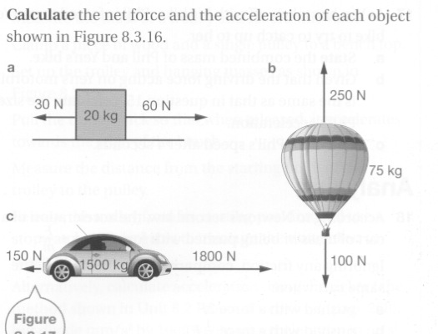

(6)

